Smart VMS PRD v2.2
Product Requirements Document (PRD)
Smart Visitor Management System (VMS)
Version: 2.2 · Date: July 2026 · Status: For Sign-off
Owner: Product Management · Reviewers: Engineering, Security, Legal/Compliance, Facilities

1. Executive Summary & Problem Statement

1.1 Executive Summary
This document defines a next-generation, multi-tenant SaaS Smart Visitor Management System (VMS) that secures the complete visitor journey — pre-registration, arrival, identity verification, on-site movement, and check-out — using biometrics, swipe/RFID/NFC/mobile-wallet credentials, and an AI-driven enrichment layer.
The product is positioned against global incumbents (Envoy, iLobby, HID SAFE, Verkada Guest) and Indian market leaders (Veris, VAMS Global) on three defensible differentiators:
- Legacy Paper Slip / Gate Pass Digitization — an AI-driven “slip conversion” flow (kiosk camera + OCR) that no benchmarked competitor offers fully, and which is everyday reality in Indian factories, government campuses, and older facilities.
- Advanced Edge AI Layer — bundled facial recognition with liveness, tailgating/piggybacking detection via CCTV, predictive lobby traffic forecasting, and an LLM-based conversational kiosk avatar.
- India-Specific Compliance — native DPDP Act 2023 support (consent capture, purpose limitation, auto-purge), Aadhaar-sensitive identity verification (verify without storing numbers), and native WhatsApp Business integration for all invites and alerts.

1.2 Problem Statement — Legacy Logs vs. Digital Assurance
Manual visitor logbooks and legacy sign-in kiosks fail on four axes:
Axis | Legacy reality | Digital assurance target
Speed | 3–8 min manual entry, queues at peak hours | < 30 s pre-registered, < 90 s walk-in
Identity | Name written in a register; no verification of the person | Biometric 1:1/1:N match ≥ 99.5% accuracy, FAR < 0.1%
Security | No watchlist screening; paper gate passes accepted at face value | 100% screening coverage; slips digitized, verified, and host-confirmed
Compliance | Registers retained indefinitely, visible to every subsequent visitor | Consent-first capture, purpose limitation, automatic purge, immutable audit

Organizations need a system that verifies visitor identity with high assurance, integrates with physical access control in real time, and provides live visibility, analytics, and audit-ready records — without ripping out existing gate-pass culture or hardware on day one.

1.3 Goals & Success Metrics
Goal | Metric | Target
Faster check-in | Average check-in time | < 30 s (pre-registered), < 90 s (walk-in)
Identity assurance | Biometric verification accuracy | ≥ 99.5% (FAR < 0.1%)
Security | Watchlist screening coverage | 100% of check-ins
Compliance | Audit-ready visitor logs | 100% retention per policy; zero unpurged expired records
Host experience | Host notification latency | < 10 s
Adoption | Pre-registration rate | ≥ 60% within 6 months of go-live

1.4 In Scope / Out of Scope
In scope (Phase 1–4): Visitor check-in/out; pre-registration & invitations; biometric enrollment & verification; RFID/NFC/printed-QR/mobile-wallet badge issuance; watchlist & sanctions screening; host notifications & workflows; emergency evacuation mustering with mobile muster app; dashboards & reporting; legacy paper-slip digitization; AI camera features; multi-site administration; integrations.
Out of scope (Phase 1): Employee time & attendance; parking management (beyond ANPR entry in Phase 3); long-term contractor HR onboarding.

2. Comprehensive User Personas

2.1 Visitor — “Priya”, consultant
Guests, contractors, vendors, interviewees, and delivery personnel. Priya arrives with a QR invite on WhatsApp or, at older client sites, a paper gate pass. She wants a fast, dignified check-in, clear wayfinding, and confidence that her ID photo will not live in a database forever. Pain today: repeating her details at every visit, queues, opaque data handling. Success: < 30 s check-in, one-time biometric enrollment reused with consent, visible privacy notice, auto-deleted data.

2.2 Host (Employee) — “Rahul”, engineering manager
Invites and receives visitors. Creates invites from the portal, Outlook/Google Calendar, or in bulk via CSV. Pain today: doesn't know when guests arrive; front desk phones him. Success: invite created in < 60 s; arrival notification in < 10 s on WhatsApp/Slack/Teams/push with one-tap actions (“On my way”, “Delay 10 min”, “Delegate”, “Deny”).

2.3 Front-Desk / Security Officer — “Kavita”
Manages check-ins, exceptions, badges, deliveries, and the paper-slip conversion flow. Pain today: manual registers, judging handwritten passes at face value, no tools when biometrics fail. Success: exception queue with clear approve/hold/deny actions; slip conversion in < 60 s; manual verification fallback when a biometric match fails.

2.4 Security Admin — “Deepak”
Configures watchlists, access policies, zones, and camera-AI thresholds. Reviews held check-ins and camera alerts. Success: watchlist hits held at the kiosk 100% of the time with mandatory human review before any denial; every decision logged with actor, timestamp, and reason.

2.5 Facility / Compliance Manager — “Rohan”
Owns reports, audits, retention policy, and evacuation musters. Success: DPDP-compliant retention with provable auto-purge; evacuation roll-call live in < 5 s; CSV/PDF audit exports; scheduled report delivery.

2.6 System Admin (IT) — “Meera”
Handles tenant setup, SSO (Azure AD/Entra, Okta, SCIM), integrations, user roles, and hardware fleet (Android Enterprise EMM for kiosks, Zebra printers). Success: SCIM-provisioned roles; edge-connector health dashboard; zero credentials stored on kiosks.

3. Detailed Functional Requirements

3.1 Pre-Registration & Invitations

Host-initiated invitations
- Hosts create invites: single, recurring, bulk via CSV, or via Outlook 365 / Google Calendar integration (a meeting with an external attendee proposes an invite).
- Visitor receives an email / SMS / WhatsApp invite containing a QR pass, directions, parking info, and required documents (NDA, safety briefing, ID upload).
- Visitor may pre-upload a government ID and a selfie (optional, consent-gated) for faster biometric matching on arrival.
- Approval workflows for restricted zones or high-security visits (multi-level approvals with SLA and escalation).

Visitor-initiated requests — public self-service portal
Not every visit starts with a host. First-time vendors, interview candidates, and anyone without a standing relationship with a host contact need a way to request a visit themselves, without waiting for someone else to create an invite first. A public web portal (no login required) covers this:
- Visitor opens the portal link (shared on the company site, in a lobby QR code, or in an email signature) and submits their name, phone or email, the host they're visiting, purpose of visit, and group size/type (individual or group).
- Visitor may optionally upload a government ID and a selfie at submission time, same consent-gated document flow as a host-issued invite, so verification is faster if the visit is approved.
- On submission the visitor receives a tracking reference (e.g., REQ-10231) and can look up live status — pending, approved, or denied — on the same portal using that reference, with no account needed.
- The named host receives the same instant Confirm / Deny prompt used for any other approval (Section 3.6), with the same response-time SLA and escalation chain.
- On approval, a QR/check-in code is generated and sent to the visitor on their provided contact channel (WhatsApp/email/SMS); on denial, the visitor sees the denial on the tracking page and the host's reason is logged.
- This is the front door for anyone without a pre-existing host relationship, complementing — not replacing — host-initiated invites; both funnel into the same approval and status pipeline below.
A visitor who submits the public visitor-portal form (rather than being invited by a host) enters the Requested state immediately — visible to reception and admin the instant it's submitted, not only inside the host's notification queue. On host approval it becomes Registered (code/QR issued, not yet arrived); on denial it becomes Denied. See Section 3.13 for the full state model, and Section 3.11 for the equivalent naming used by the legacy paper-slip flow.
High-security (“secure”) visits additionally require sign-off from both the host and a security reviewer before a badge is issued — a two-step approval distinct from a standard single-approver request. This dual sign-off is tracked as its own status (Awaiting dual sign-off, Section 3.13) so reception and the visitor-facing status screen can show precisely which approval is still outstanding.

3.2 Check-In (Kiosk / Reception / Mobile)
- Self-service kiosk (Android tablet, Section 5) with multilingual UI (Hindi + 10 regional languages + English) and WCAG 2.1 AA accessibility.
- Check-in methods, presented as a single choice screen at the kiosk: QR scan, face check-in, fingerprint check-in, iris check-in, phone number/OTP, or manual registration by the visitor/receptionist.
- Automatic ID document scanning with OCR + authenticity checks (passport MRZ, driver's licence, national ID hologram/font/security-feature heuristics).
- Digital signature capture for NDAs, safety waivers, and privacy consent — stored against the visit record with document version.
- Photo capture for badge printing; health/safety questionnaires configurable per site.

3.3 Biometrics
- Facial recognition for identity verification and touchless repeat check-in, with explicit consent capture.
- Fingerprint check-in offered as a standard kiosk method alongside face and iris — not restricted to high-security sites — with a dedicated sensor module (Section 5).
- Iris recognition offered as a higher-assurance kiosk check-in option for sites that need it (data centers, high-security zones); requires a dedicated iris-capable camera module, priced as a site pack outside the standard per-lobby CapEx ceiling (Section 6), the same way fingerprint hardware is scoped.
- At the kiosk, the visitor picks their preferred method (face, fingerprint, or iris) from the check-in screen; all three route through the same liveness-check and match-against-enrolled-visitor pipeline, so the approval/status logic (Section 3.13) is identical regardless of which biometric was used.
- Liveness detection (presentation-attack detection) blocks photo/video/mask spoofing — method-appropriate for each modality (face: presentation-attack detection; fingerprint: liveness/spoof-material detection; iris: live-eye detection).
- Biometric templates stored encrypted and segregated; raw images purged per retention policy (templates retained, raw face/ID/fingerprint/iris images deleted first).
- Fallback flow when a biometric match fails, on any modality: manual verification by security officer, logged.
- 1:1 verification (pre-registered visitors) and 1:N identification (returning visitors / watchlist).
- Aadhaar-sensitive handling: where Aadhaar is presented, verify identity (e.g., offline XML/QR verification or masked capture) without storing the Aadhaar number; only a verification result and masked reference are retained.

3.4 Swipe / Credential Management
- Issue temporary access credentials at check-in: RFID/NFC swipe cards, printed QR badges (Zebra ZD-series thermal), or mobile credentials (Apple/Google Wallet).
- Credentials scoped by zone, floor, time window, and escort requirement; auto-expire at checkout or end of visit window.
- Real-time provision/deprovision through access-control integrations (Lenel OnGuard, Genetec, HID, Honeywell, Brivo, Kisi) via the on-premises edge connector.
- Turnstile / speed-gate integration for badge-tap or face-based entry.
- Lost-card handling: instant deactivation and reissue, audit-logged.

3.5 AI Enrichment
- Watchlist & sanctions screening: real-time matching of visitor identity/face against internal blocklists, VIP lists, and (where legally permitted) external databases; alerts to security.
- ID fraud detection: AI checks for tampered or fake documents.
- Anomaly detection: tailgating attempts, overstays, repeated failed check-ins, off-hours visits, zone violations.
- Smart visit categorization: auto-classify visit purpose from invite text; route approvals accordingly.
- Predictive lobby analytics: forecast visitor traffic for staffing and lobby capacity planning.
- Conversational assistant: LLM-based multilingual kiosk/web avatar that greets visitors, answers FAQs, guides check-in and wayfinding, and escalates to a human on request — with guardrails (no policy overrides, no personal-data disclosure).
- Auto-enrichment of visitor profiles: company info, visit history, relationship mapping — subject to consent and privacy policy.
- VIP recognition: discreet notification to hosts/reception when a VIP arrives.

3.6 Host Notifications & Workflow
- Instant arrival notifications via WhatsApp Business, email, SMS, Slack, Microsoft Teams, or push — target latency < 10 s.
- One-tap host actions: “On my way,” “Delay 10 min,” “Delegate to colleague,” “Deny.”
- Escalation chain if the host does not respond within a configurable time (e.g., 2 min → team channel, 5 min → floor admin).

3.7 Check-Out & Overstay Management
- Checkout via kiosk, badge drop-box (RFID sensing), face scan at exit, or automatic checkout on access-control exit event.
- Automatic overstay alerts to host and security; auto-expiry of credentials.
- Optional visit summary emailed to the visitor with a feedback survey (NPS).

3.8 Emergency & Evacuation (Mustering)
- One-tap evacuation mode: all visitor badges frozen; live roll-call of everyone on site (visitors + employees if integrated).
- Mobile muster app for wardens to mark people safe at assembly points, offline-tolerant with sync.
- Real-time missing-person list pushed to emergency responders; AI-assisted zone-clearance cross-check (Section 3.12).

3.9 Dashboards, Reporting & Analytics
- Live occupancy dashboard: who is on site, by zone/building.
- Reports: daily visitor logs, host activity, average check-in times, peak hours, no-shows, watchlist hits, compliance/audit exports (CSV/PDF).
- Scheduled report delivery and API access to analytics data.

3.10 Administration
- Multi-site, multi-tenant configuration with site-specific branding, flows, and legal documents (versioned; re-sign on new version).
- Role-based access control (RBAC) with granular permissions; SCIM-provisioned.
- Configurable visitor types (guest, contractor, vendor, interview, delivery), each with its own flow.
- Document/certification tracking for contractors (insurance, safety-training expiry).
An expired or missing contractor document blocks badge issuance outright — the visit is placed in the Held state (Section 3.13) with a compliance reason attached, the same review queue used for watchlist matches, so security has one place to clear either kind of hold.

3.11 Legacy Gate Pass / Paper Slip Handling — Step-by-Step Logic
Visitors may arrive with a physical slip (gate pass, appointment slip, or department authorization note). The system must digitize and verify these rather than accept them at face value. A slip authorizes the visit; biometrics/ID verify the person. A slip alone never grants access.

Path A — System-issued slips (barcode/QR/reference number):
- 1. Kiosk or receptionist scans the code or types the reference.
- 2. VMS retrieves the linked visit record; validity window and status are checked.
- 3. Check-in proceeds as a pre-registered visit: identity verification (3.11 step B4) + badge issuance.

Path B — Handwritten / legacy slips (no digital record):
- 1. Capture: Receptionist (or kiosk camera) photographs the slip. Image quality is validated (blur/glare check); re-capture prompted if needed.
- 2. OCR extraction: Cloud OCR + AI engine extracts visitor name, host/department, issuing authority, purpose, and date. Confidence score per field; low-confidence fields flagged for the receptionist to correct.
- 3. Record creation: A digital visit record is created with the slip image attached as evidence, status = Awaiting approval (host confirmation pending).
- 4. Identity binding: The slip-holder completes ID scan or biometric verification. The scanned-ID name is fuzzy-matched to the slip name; mismatch raises a fraud flag (step 6).
- 5. Mandatory real-time confirmation: The named host or issuing department receives an instant Confirm / Deny prompt (WhatsApp/app/Slack/Teams). Entry is blocked until confirmation. Configurable timeout → escalation → default deny.
- 6. Fraud & anomaly controls: AI flags (a) duplicate use of the same slip reference, (b) slips presented outside their valid date/time, (c) slip-name vs scanned-ID mismatches, (d) repeated denied-slip attempts by the same individual. Flags route to the security review queue (Held state, Section 3.13).
- 7. Badge issuance: On confirmation and clear screening, a zone- and time-limited credential is issued (3.4). On denial, entry is refused and logged for audit.
- 8. Audit trail: Slip image, OCR data + confidences, confirming approver, timestamps, and any override reasons are stored immutably against the visit record.
- 9. Transition plan: Departments currently issuing paper slips are onboarded to generate digital passes (QR via SMS/WhatsApp/email) from the portal; the paper-slip flow remains a documented fallback for visitors without phones or during outages.
This intermediate state is named Awaiting approval, matching the single status vocabulary used everywhere else in the product — kiosk walk-ins, portal requests, and reception all funnel into the same nine-state model (Section 3.13).

3.12 AI Camera & Computer Vision Features — Step-by-Step Logic
Cameras may be dedicated VMS cameras (entry points) or existing CCTV integrated via the video platform (Section 5). All camera AI is subject to the governance block below.

Entry & identity verification:
- Facial recognition entry: (1) camera at gate/turnstile detects a face → (2) liveness check → (3) 1:N match against enrolled, consented visitors → (4) match ≥ threshold → door-release signal via edge connector → (5) event + confidence logged. No match → fall back to badge tap or kiosk.
- Liveness / anti-spoofing: presentation-attack detection blocks photos, videos, and masks used to impersonate an enrolled visitor.
- Badge-vs-face mismatch detection: on badge tap, the camera verifies the presenter is the person the badge was issued to; mismatch → entry blocked pending review + security alert with video clip.
- ANPR/LPR parking entry (Phase 3): licence-plate recognition at the barrier auto-admits vehicles of expected visitors and links the plate to the visit record.

Security surveillance & anomaly detection:
- Tailgating / piggybacking: detects ≥ 2 people passing on a single credential at doors/turnstiles; real-time alert with video clip.
- Watchlist face matching on CCTV: flagged or banned individuals detected on any integrated camera, including before they reach reception (human review mandatory before action).
- Loitering & zone-intrusion: alerts when a visitor lingers abnormally or enters a zone outside their credential scope; cross-referenced with badge data.
- Abandoned-object detection: flags unattended bags/items in lobbies and common areas.
- Behavioral anomaly scoring: models normal movement per visitor type and scores each visit for risk (off-hours presence, unusual zones, frequency spikes).

Safety & compliance:
- PPE detection: verifies helmets, vests, goggles before permitting entry to industrial/shop-floor zones.
- AI-assisted evacuation: cameras confirm which zones are cleared and cross-check against the live muster list (3.8).

Operations & experience:
- People counting & occupancy heatmaps, queue analytics (alert reception to open counters), AI receptionist (voice/chat avatar), smart scheduling & daily security digest.

Governance requirements for all camera AI (non-negotiable):
- 1. Explicit signage and consent capture where required by law; region-specific enable/disable per feature.
- 2. Confidence thresholds with mandatory human review before any denial or security action.
- 3. All detections logged with video evidence, reviewer, and outcome for audit.
- 4. Bias testing and periodic accuracy benchmarking (NIST FRVT-tested engines) for all face matching.
- 5. Video analytics processed at the edge where possible; retention and purge per privacy policy (Section 9).
Recommended rollout order: facial recognition + liveness → tailgating detection → ANPR parking → AI receptionist, then surveillance analytics in later phases.

3.13 Visit Status Lifecycle
Every visit record, regardless of which channel created it (kiosk walk-in, reception, host portal invite, paper slip, or the public visitor portal), moves through the same nine-state model. This section makes explicit a lifecycle that was previously implicit across Sections 3.1, 3.2 and 3.11; it does not change any of the business rules described there.
Status | Meaning | Entered from | Exits to
Requested | Submitted via the public visitor portal; on the books but the host has not yet decided and the visitor is not on site. | Visitor portal form submission (3.1) | Registered (approved) or Denied
Registered | Host approved; a QR/code has been issued but the visitor has not yet arrived. | Requested (approved), or a direct host-portal invite (3.1) | Checked-in (on arrival) or expires unused
Awaiting approval | Visitor physically at the kiosk/reception (walk-in or paper slip); waiting on a single approver. | Kiosk walk-in requiring sign-off (3.2), Paper slip Path B (3.11) | Checked-in or Denied
Awaiting dual sign-off | High-security (“secure”) visit; needs both host and security approval before a badge is issued. | Kiosk/reception walk-in flagged as secure (3.1) | Checked-in (both approve) or Denied
Held | Watchlist match or expired compliance document (e.g., contractor permit). No badge issued automatically — always a human decision. | Watchlist screening (3.5) or contractor document check (3.10) | Checked-in (released) or Denied
Checked-in | Badge issued, visitor on site. | Any approval path clearing, or a frictionless pre-registered check-in | Checked-out, Safe (evacuation), or Denied (host revokes)
Denied | Rejected by host or security at any stage. No credential is active. | Any approval or Held state | Terminal
Checked-out | Visit ended; credential deactivated. | Checked-in (kiosk, badge drop-box, face scan, or access-control exit event) | Terminal
Safe | Marked accounted-for during an evacuation muster. | Checked-in, during Evacuation mode (3.8) | Reverts to Checked-in when evacuation mode ends

Design rule carried through every channel: a visitor is never silently invisible between submission and a badge decision. Whichever door they came through — website, kiosk, reception desk, or a paper slip — there is always a status, and that status is visible in the live visitor list to reception, hosts, and security, not only inside one role's private queue.

4. User Stories & Technical Acceptance Criteria
US-01 — Pre-registered check-in.
As a visitor, I want to check in with the QR pass from my WhatsApp invite, so that I am badged in under 30 seconds. AC: scanning a valid QR retrieves the visit in < 1 s; face verification completes in < 1.5 s; total kiosk dwell < 30 s at p90; host notified < 10 s; badge scoped to zone + time window.
US-02 — Walk-in.
As a walk-in visitor, I want to scan my ID and sign the NDA at the kiosk, so that I can get a badge without pre-registration. AC: OCR extracts name/document number with ≥ 95% field accuracy on supported IDs; watchlist screened 100%; host approval required before badge; end-to-end < 90 s at p90.
US-03 — Paper slip conversion.
As a receptionist, I want to photograph a handwritten gate pass and have the system extract and verify it, so that a slip never grants entry unverified. AC: slip image + OCR fields + confidences stored; named host receives Confirm/Deny in < 10 s; entry blocked until confirmation (visit sits in Awaiting approval, Section 3.13); ID-name vs slip-name mismatch raises a fraud flag; duplicate slip reference rejected; full audit trail retained.
US-04 — Host arrival actions.
As a host, I want one-tap responses on the arrival notification, so that reception knows what to do without calling me. AC: actions On-my-way / Delay-10 / Delegate / Deny reflected at reception in < 3 s; non-response escalates per configured SLA; Deny deactivates any issued credential immediately.
US-05 — Watchlist hold.
As a security admin, I want watchlist matches held at the kiosk for human review, so that no automated denial occurs. AC: match → status Held, badge not issued, alert raised; only a user with “Approve/deny” permission can release or reject; decision + reason logged immutably.
US-06 — Evacuation muster.
As a compliance manager, I want a one-tap evacuation roll-call, so that I can account for everyone on site in under 5 seconds. AC: evacuation freezes all visitor credentials < 2 s; live roll-call renders < 5 s; warden app marks safe offline and syncs; missing-person list exportable and shareable with responders.
US-07 — DPDP auto-purge.
As a compliance manager, I want visitor data purged automatically per policy, so that we honour purpose limitation and deletion rights. AC: retention configurable per tenant/site; nightly purge job erases expired records and raw biometric images (templates per separate shorter policy); each purge writes an audit entry with count, policy, and actor; right-to-erasure requests completed ≤ 72 h.
US-08 — Credential auto-expiry.
As a security officer, I want visitor credentials to die at checkout or window end, so that no live badge leaves the building. AC: deprovision command reaches the access-control panel via edge connector < 2 s after checkout; end-of-window expiry enforced panel-side even if cloud is unreachable.
US-09 — Tailgating alert.
As a security officer, I want a real-time alert with a video clip when two people pass on one credential, so that I can respond immediately. AC: detection-to-alert < 3 s; clip attached; alert requires review disposition (confirmed/false-positive) which feeds accuracy benchmarking.
US-10 — SSO & roles.
As an IT admin, I want SCIM-provisioned roles from Azure AD/Okta, so that joiners/leavers are handled automatically. AC: SCIM create/update/deactivate reflected < 5 min; six baseline roles with granular permissions; all permission changes audit-logged.
US-11 — Website pre-registration visibility.
As a receptionist or admin, I want a visitor's website registration to be visible the moment it's submitted — not only after the host acts — so that front desk has full visibility into who is expected. AC: submission creates a visit record with status Requested, visible in the live visitor list immediately; host approval transitions it to Registered with a code issued; host denial transitions it to Denied; both transitions are audit-logged with actor and timestamp.
US-12 — Choice of biometric check-in method.
As a visitor, I want to check in using whichever biometric method I'm enrolled for — face, fingerprint, or iris — so that I'm not forced into one modality. AC: kiosk home screen presents face, fingerprint, and iris as separate check-in options alongside QR/OTP/manual; whichever is chosen runs the same liveness-check-then-match pipeline and produces an identical downstream status/approval outcome (Section 3.13); a failed match on any modality falls back to manual verification by a receptionist or security officer, logged.

5. Hardware Track & Specifications

5.1 Kiosk Tablets — Android (mandated)
Item | Minimum baseline | Recommended
Model | Samsung Galaxy Tab A9+ 11" (or equivalent Lenovo Tab), Android 14+ | Samsung Galaxy Tab Active5 (rugged, Knox) or Tab S9 FE, Android 14+
Rationale | Android Enterprise fleet security: zero-touch enrollment, dedicated-device (kiosk lock-task) mode, managed Google Play, remote wipe via EMM (Knox / Intune / Workspace ONE) | Rugged build (MIL-STD/IP rating) for industrial lobbies; Samsung Knox hardware-backed security; longer update commitment
Camera | ≥ 8 MP front camera — supports high-resolution face capture for biometric liveness checks | ≥ 12 MP front camera with anti-glare mounting position
OS policy | Android 14+ with minimum 4 years of security-update commitment from OEM | Same, Enterprise Edition / extended-support SKU
Mounting | Locking enclosure, floor or counter stand, cable-secured, powered (PoE-to-USB-C or wired adapter) | Height-adjustable/accessible mount (WCAG reach ranges)
Peripherals | Front-facing QR/barcode scan via camera; USB-C/OTG for scanners | Dedicated 2D scanner for high-throughput lobbies; NFC on-tablet for wallet-pass taps
Biometric add-ons | None required for QR/face (uses the front camera above) | Optional USB fingerprint sensor module and/or iris-capable camera module, for sites offering those check-in methods (Section 3.3)

5.2 Badge Printers — Zebra Thermal Desktop, ZD Series (mandated)
Item | Minimum baseline | Recommended
Model class | Zebra ZD421 direct thermal | Zebra ZD621 direct thermal
Rationale | Heavy-duty enterprise/industrial duty cycle; direct thermal = zero ink/ribbon OpEx | Higher print speed and resolution for peak lobbies
Connectivity | USB + LAN | LAN + Wi-Fi
Options | — | RFID/NFC encoder module for encoded credentials
Media | Adhesive visitor labels (expiring stock optional) | Expiring badge stock (visual void after ~24 h)

5.3 Document / ID Scanners
Item | Minimum baseline | Recommended
Type | Commercial-grade flatbed at reception desk | Passport/ID swipe scanner (full-page MRZ + UV/IR)
Purpose | Highly accurate OCR capture of national IDs at receptionist desks | Authenticity checks (hologram/UV) feeding fraud detection
Fallback | Kiosk camera capture with quality gating | —

5.4 Supporting hardware
RFID/NFC card stock + desktop encoder (where swipe credentials used); optional dedicated entry camera per turnstile (or reuse existing CCTV via integration); edge-connector mini-PC (fanless, on-prem) per site for access-control and printer bridging.

6. Hardware Cost & Budget Constraints Block
Per-lobby CapEx ceiling (strict): ₹2,50,000 (~US$3,000) per standard lobby. Deployments must be scalable to hundreds of lobbies; any bill of materials exceeding the ceiling requires VP approval with written justification.
Indicative per-lobby BOM (standard configuration — validate pricing at procurement):
Component | Qty | Indicative cost (₹)
Android tablet (Galaxy Tab A9+ class) + locking stand + power | 1 | 25,000–45,000
Zebra ZD421 direct thermal + media starter | 1 | 35,000–45,000
ID flatbed/swipe scanner (reception) | 1 | 15,000–60,000
RFID card stock (500) + encoder | 1 | 20,000–30,000
Edge connector mini-PC | 1 per site (amortized) | 15,000–25,000
Cabling, mounting, signage (consent notices) | — | 10,000–15,000

Cost-optimization rules:
- 1. Direct thermal printing only — eliminates ink/ribbon OpEx entirely.
- 2. Utilize existing Android tablet stock where tenants already own EMM-enrolled tablets meeting the baseline (Android 14+, ≥ 8 MP front camera).
- 3. Commercial off-the-shelf components only — no proprietary or single-source hardware; every component must have ≥ 2 supply options.
- 4. Reuse existing CCTV via video-platform integration instead of new cameras wherever coverage permits.
- 5. High-security add-ons (fingerprint module, iris scanner module, passport scanner, dedicated cameras) are priced as optional site packs, outside the standard ceiling.

7. Integration Ecosystem
Integration-first architecture with an on-premises edge connector (outbound-only connection to cloud; local queue for offline tolerance).
Category | Systems
Access control | Lenel OnGuard, Genetec, HID, Honeywell, Brivo, Kisi (OSDP/API-first)
Identity / SSO | Azure AD / Entra, Okta, Google Workspace — SAML/OIDC + SCIM
Calendars | Outlook 365, Google Calendar
Communications | WhatsApp Business (native, Phase 1), Slack, MS Teams, SMS gateways (Twilio)
HR / Directory | Workday, SAP SuccessFactors (host sync)
CCTV / Video | Verkada, Milestone (link visit events to video)
Watchlists | Internal lists; third-party screening APIs where permitted
Printing | Zebra ZD series (LAN/Wi-Fi)
APIs | REST + webhooks for all core objects (visits, visitors, credentials, events)

8. Non-Functional Requirements
- Performance: kiosk check-in response < 2 s; face match < 1.5 s; 500 concurrent check-ins per site cluster; host notification < 10 s.
- Availability: 99.9% uptime SLA; kiosk offline mode — check-in continues locally and syncs when connectivity returns.
- Scalability: multi-tenant SaaS; 1,000+ sites; millions of visit records.
- Security: AES-256 at rest, TLS 1.2+ in transit; biometric templates encrypted and segregated from PII; SOC 2 Type II; ISO 27001; regular pen-testing; immutable audit logs.
- Privacy & compliance: DPDP Act 2023 native (consent capture, purpose limitation, configurable retention & auto-purge, right to erasure); GDPR/CCPA-ready; BIPA/biometric-consent workflows where applicable; data-residency options (India region for Indian tenants); Aadhaar never stored.
- Accessibility: WCAG 2.1 AA on kiosk and web (reach ranges, contrast, screen-reader labels, timeout extensions).
- Localization: Hindi + 10 regional languages + English at launch on the kiosk; RTL-ready framework.
- Auditability: every identity decision (biometric match, watchlist hit, override, purge) logged with actor, timestamp, and reason.

9. 4-Phase Implementation Roadmap
Phase | Timeline | Scope
Phase 1 — MVP | 0–4 months | Pre-registration (portal/calendar/CSV), kiosk check-in/out, ID scan (OCR), photo badge printing (Zebra), host notifications incl. WhatsApp, dashboards, DPDP consent + auto-purge, basic reports, offline kiosk mode
Phase 2 — Biometrics & Access | 4–8 months | Facial recognition + liveness, swipe/RFID credential issuance, access-control integration via edge connector, watchlist screening + review queue, evacuation module + muster app, Slack/Teams
Phase 3 — AI, Anomalies & Paper Slips | 8–12 months | Paper-slip conversion flow (3.11), AI anomaly detection (tailgating, badge-face mismatch, overstay patterns), predictive lobby analytics, conversational kiosk avatar, contractor compliance, deliveries module, mobile wallet passes, ANPR parking, virtual receptionist
Phase 4 — Federation & Depth | 12+ months | Multi-site federation & watchlist sharing, advanced ESG reporting, marketplace/API ecosystem, fingerprint module

Prototype scope note
The click-through UX prototype referenced throughout this document simulates the full Phase 1–3 workflow set (including paper-slip entry and dual-approval) at the interaction/status level so stakeholders can validate flows before OCR, biometrics, and access-control integrations are built. It does not perform live OCR, face matching, or panel provisioning — those remain scoped to Phases 1–2 as shown above.

10. Risks & Mitigations
Risk | Mitigation
Biometric privacy regulations vary by region | Configurable consent flows; non-biometric fallback always available; legal review per market; region-specific feature switches
Face-recognition bias / false rejects | NIST FRVT-tested engines only; periodic bias benchmarking; human-in-the-loop fallback; confidence thresholds with mandatory review
Access-control integration complexity | Standardize on OSDP/API-first partners; edge-connector abstraction layer; certification matrix per panel
Kiosk hardware failures / drops | MDM health monitoring; offline mode; receptionist web check-in as backup; rugged locking enclosures; spare-unit pool per region
Watchlist false positives | Confidence thresholds + mandatory human review before denial; audit of every disposition
WhatsApp template/policy changes | Twilio/SMS and email as automatic fallback channels; template pre-approval pipeline
Paper-slip fraud (forged/duplicate slips) | Identity binding, duplicate-reference detection, host confirmation mandatory, slip image evidence retained

11. Acceptance Criteria (Summary)
- A pre-registered visitor checks in via QR + face verification in < 30 s and receives a time-boxed credential.
- A walk-in scans an ID, signs the NDA, is screened against the watchlist, and is badged in < 90 s.
- A paper-slip holder is never admitted without OCR digitization, identity binding, and real-time host confirmation.
- Host is notified within 10 s of check-in with actionable buttons, on WhatsApp where enabled.
- Security can run an evacuation roll-call of all on-site visitors in < 5 s.
- All visitor data is purged automatically per configured retention policy, with an immutable audit trail.
- A website (portal) submission is visible with status Requested the instant it is submitted, and transitions to Registered or Denied the instant the host decides.

12. Visual Component — Legacy Paper Slip / Gate Pass Conversion Workflow
Editable Mermaid diagrams (render natively in GitHub, Notion, Confluence, VS Code), drawn in the same style and color legend as Section 13: purple = visitor · green = on-site (kiosk/reception, access control) · blue = VMS cloud · amber = host/external or review states · red = denial. The workflow is split into two parts; Part B starts where Part A ends. Status labels in both diagrams have been reconciled with Section 3.13's Awaiting approval / Held terminology.

Part A — Digitize the slip & bind the identity
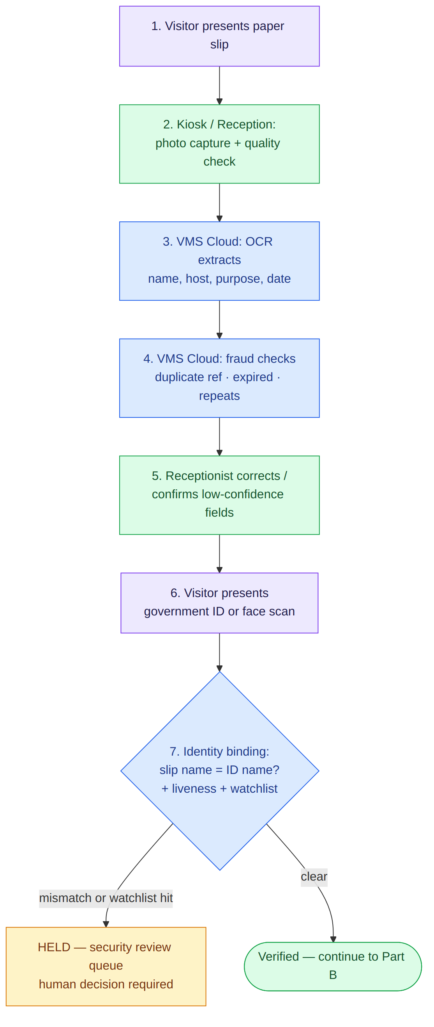

Part B — Host confirmation & credential issuance
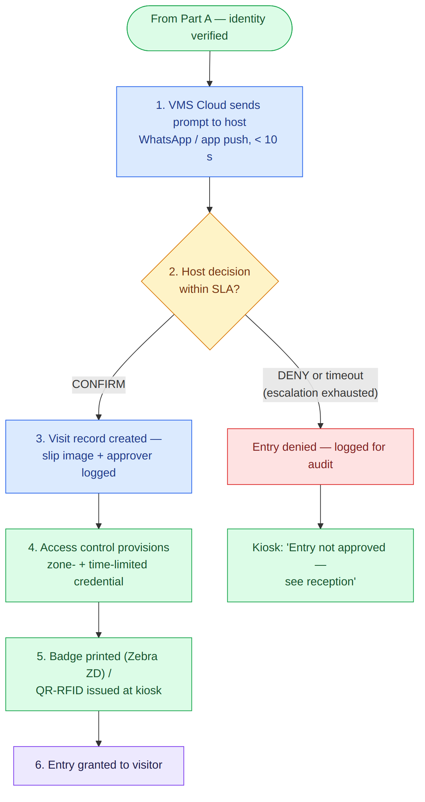
Every step in both parts is immutably audit-logged: slip image, OCR data + confidences, approver identity, timestamps, and credential lifecycle (Section 3.11, step 8).

13. System Architecture (Diagrams)

13.1 System Context — one screen view
How the four worlds connect: people's devices, our cloud, the customer's site, and third-party systems. Read left to right.
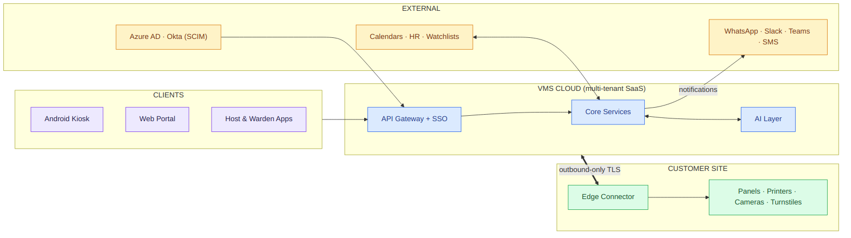

13.2 Cloud Backend — inside the box
Zoom into “VMS Cloud” from 13.1: six microservices, five AI services, four data stores.
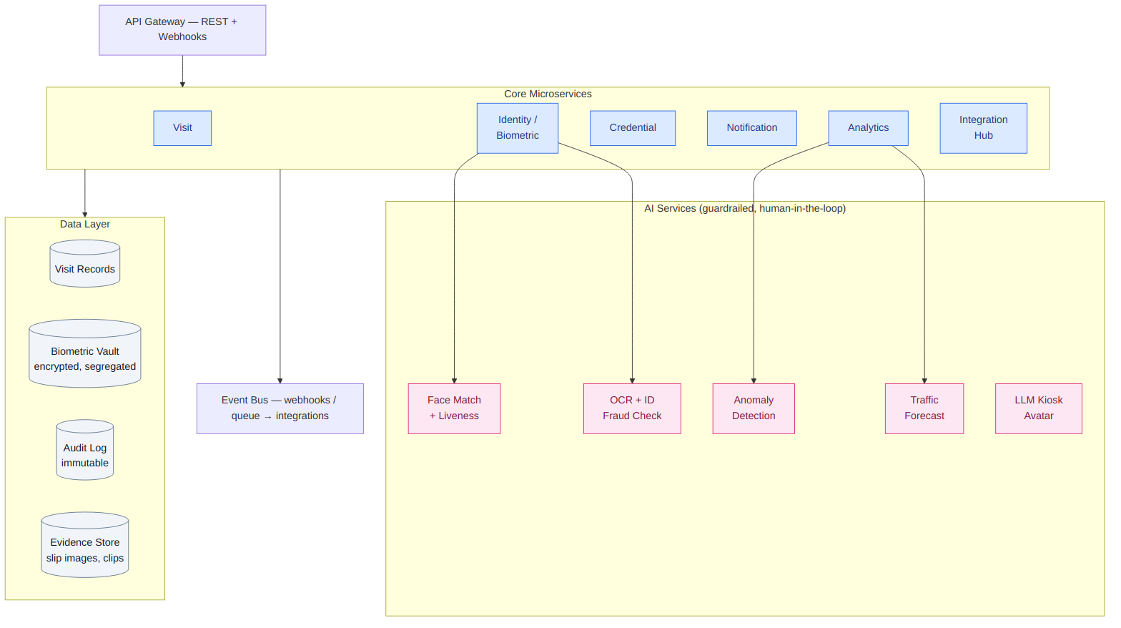

13.3 Site Deployment — what gets installed per lobby
Everything inside the green box fits the ₹2.5L per-lobby CapEx ceiling (Section 6).
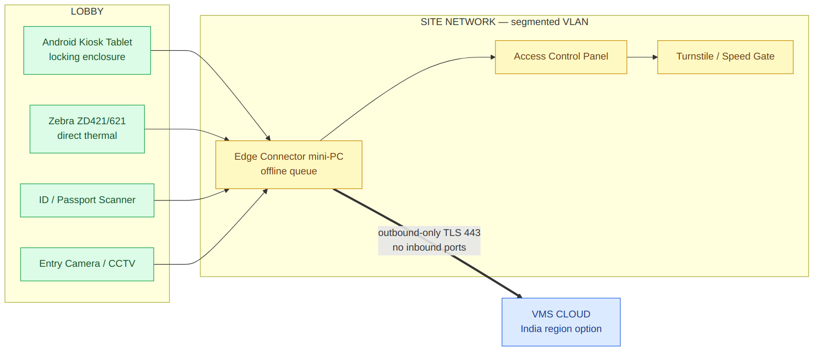
Resilience rules encoded here: the edge connector initiates all cloud traffic (no inbound firewall holes); the kiosk keeps checking people in offline and syncs later; badge expiry is enforced on the panel itself, so a dead internet link never leaves a live credential active (US-08).

13.4 Check-In Decision Flow — pre-registered visitor
Top-to-bottom; green path = happy path with performance targets; branches show every exception exit.
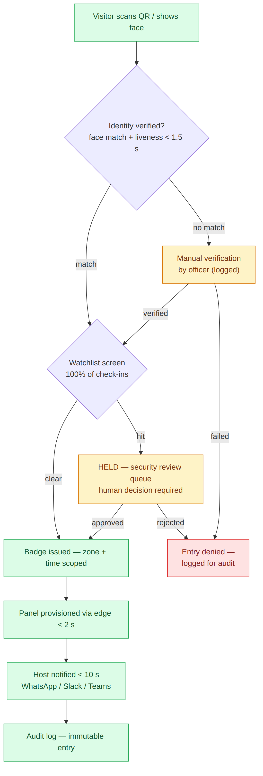

14. Technology Stack & Implementation Approach
This section summarizes the approved implementation technology direction from the companion document “Smart VMS — Technology Stack & Implementation Scope v1.0,” which remains the authoritative source for detailed architecture decisions, security controls, and sign-off items.

14.1 Recommended direction
A Python-led, Azure-first hybrid architecture: Python owns the multi-tenant SaaS transactional and workflow core; PostgreSQL is the system of record; React provides web portals; Flutter provides the Android kiosk and mobile experiences; narrowly scoped native Android modules handle device SDKs; C#/.NET provides the site edge connector and Windows/.NET SDK integrations; Go is reserved for optional lightweight protocol and telemetry agents. The design keeps business transactions and policy decisions in the cloud while locating device, access-control, and offline enforcement functions on the customer site.

14.2 Stack by layer
Layer | Selected technology | Implementation scope
Web portals | React, TypeScript, Next.js or Vite, TanStack Query, i18next | Public request portal; host portal; reception/security console; tenant administration; dashboards; WCAG-compliant, localized web UI.
Kiosk & muster app | Flutter/Dart; native Kotlin/Java platform channels | Android kiosk UI, offline cache/sync, QR/OTP, consent/signature, capture guidance, muster app. Native modules isolate USB, NFC, camera, and biometric vendor SDKs.
SaaS core | Python 3.12+, FastAPI, Pydantic v2, SQLAlchemy 2, Alembic | Tenant/site policy, visitor and visit lifecycle, approvals, consent, retention, RBAC, reporting APIs, workflow orchestration, integration contracts.
AI & data processing | Python, FastAPI/gRPC, OpenCV, ONNX Runtime/TensorRT | OCR orchestration, image quality, paper-slip extraction, provider normalization, forecasting, later CV/LLM functions — isolated from transactional requests.
Edge connector | .NET 8/9 LTS, C#, Worker Service, Docker/Windows Service | Outbound-only site connector; access-control panels; vendor SDKs; printer/local hardware; durable local command queue; panel-side credential expiry.
Optional protocol agent | Go | Optional Linux-native OSDP/TCP/MQTT/ONVIF relay, camera-event forwarding, telemetry. Not required for first release.
Transactional data | Azure Database for PostgreSQL Flexible Server | Tenant-aware transactions, lifecycle, policies, consent metadata, credentials, audit/event records, read models.
Cache / coordination | Azure Cache for Redis | QR/OTP expiry, rate limiting, cache, ephemeral presence, distributed coordination.
Messaging | Azure Service Bus; transactional outbox in PostgreSQL | Reliable command/event transport, retries, dead-letter handling, decoupled integrations.
Documents/evidence | Azure Blob Storage; immutable retention where required | Encrypted ID/slip images, signed documents, badge assets, video evidence references, protected biometric objects.
Identity/security | Microsoft Entra ID / External ID, Key Vault / Managed HSM, managed identities | OIDC/SAML/SCIM, secretless workload access, certificates, tenant key hierarchy, encryption controls.
Operations | Azure Container Apps (AKS at scale); API Management; OpenTelemetry; Application Insights; Terraform/Bicep | Deployment, API governance, observability, alerting, infrastructure-as-code, regional deployment.

14.3 Architectural principles
- Python is the single owner of visit state, approval policy, consent, tenant configuration, credential intent, and the canonical audit record.
- PostgreSQL is the durable transactional source of truth. No edge, AI, or integration component directly writes core transactional tables.
- Physical actions are asynchronous, idempotent commands: the cloud records intent; the on-premises connector executes it and returns an acknowledgement.
- Biometric engines and hardware are replaceable provider adapters. The platform stores normalized outcomes and protected references, never vendor-specific business logic.
- Offline operation is minimal, encrypted, and policy-controlled: the edge may enforce cached grants and expiry but may not invent approvals or clear a security hold.
- Start as a modular monolith plus independently deployable edge and AI services; extract cloud services only when measured scale, isolation, or ownership needs justify it.
- The visit status lifecycle (Section 3.13) is implemented as an explicit state machine enforced in the domain layer and database transaction — not merely in UI code.
- All high-risk decisions are explainable and auditable with actor, time, policy version, reason, correlation ID, and evidence reference.

14.4 Delivery phases (implementation view)
Phase | Implementation scope | Key gates
Phase 1 — Core MVP | React portals; Python SaaS core; PostgreSQL; visitor request/invitation; QR/OTP/manual check-in; consent/documents; OCR integration; badge printing; WhatsApp/email/SMS; dashboards/reports; audit/purge; Android kiosk offline foundation. | No production biometric matching, access-panel provisioning, or CCTV AI without POC.
Phase 2 — Biometric & access | Face 1:1 + liveness; selected biometric provider; C# edge connector; first access-control adapter; RFID/NFC; watchlist review; evacuation/muster; Teams/Slack. | Fingerprint/iris only where a compatible device is selected and a site-pack POC is funded.
Phase 3 — Advanced intelligence | Paper-slip workflow; AI anomaly events; tailgating/badge-face mismatch; contractor compliance; wallet pass; ANPR; forecasting; conversational assistant. | Each camera/AI feature needs privacy, accuracy, edge-capacity, and operational-review sign-off.
Phase 4 — Federation | Multi-site federation, shared policy/watchlists where lawful, marketplace APIs, broader connector coverage, advanced analytics. | Subject to multi-tenant operating model, regional legal review, scaled support readiness.

14.5 Implementation exclusions and assumptions
- Physical hardware procurement, installation, cabling, customer LAN changes, EMM licensing, and access-panel configuration are excluded unless separately contracted.
- Biometric, document-verification, CCTV, watchlist, and LLM providers are third-party products; their license, DPA, regional availability, accuracy, and SDK compatibility require customer approval before implementation.
- Only one access-control product/version and one biometric provider/device set is committed for the first production deployment; additional adapters are separately estimated.
- Face, fingerprint, and iris are not interchangeable: each modality requires a device/vendor proof-of-concept, explicit consent design, accuracy test, privacy impact assessment, and fallback flow.
- No automated denial is permitted solely from a biometric or watchlist result; authorized human review is required for security holds (consistent with Sections 3.5 and 3.13).
Open questions from v1.0 (launch regions, deployed access-control systems, fingerprint mandate, retention period, hardware budget confirmation) are resolved in Sections 5, 6, 8, and 9, except launch-region selection, which remains a business decision pending sign-off.

